Installing and setting up the Connexion Macro for Homosaurus:

1. Download the macro from the Github repository:
2. Copy it from your downloads folder to C:\Users\[username]\AppData\Roaming\OCLC\Connex\Macros

Adding a button:

1. Open Connexion and navigate to tools > tool bar editor.
2. Find the ToolsUserTools and drag your selection onto the toolbar
3. 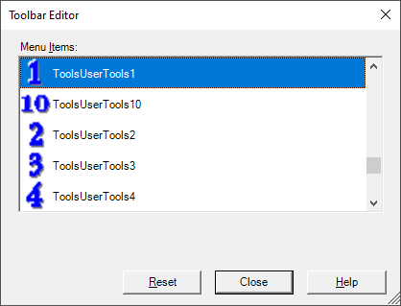
4. Find the User Tools dropdown in your toolbar and select “manage”
5. 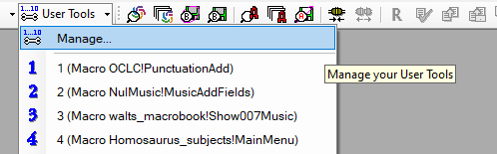
6. Select the “macro” radio button and scroll down to the Homosaurus_subjects!MainMenu macro:
7. 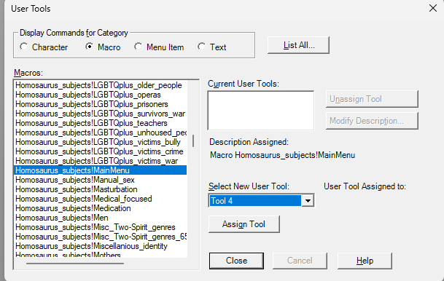
8. Choose the “tool” you moved to the toolbar and assign it.

You can also assign it to a keybind:

1. Navigate to Tools > Keymaps.
2. Choose the Macro radio button.
3. Find the Homosaurus_subjects!MainMenu macro
4. Select the keybind sequence (in Press New shortcut key) and assign.
5. 